**Willetton Senior High School**

**Year 11 AEECO 2020**

**Assessment 2**

**Name:**

**Teacher: ANSWERS Your Mark: _________/40**

**TYPE:** Short Answer

**OUTCOMES:** Outcome 1: Economic inquiry; Outcome 2: The operation of the economy

**WEIGHTING:** 7.5%

**CONTENT:** Elasticity

**Section 1:** Multiple Choice (10 marks)

**Section 2:** Short Answer (30 marks)

**Time allowed:** 50 minutes

**Conditions:**

This assessment is to be written in class without notes.

**SECTION 1: MULTIPLE CHOICE (10 marks)**

1. Which of the following statements is correct?

The demand for Nike shoes is more elastic than the demand for shoes in general.

(b) The demand for luxuries is less elastic than the demand for necessities.

(c) The demand for a narrowly defined good is less elastic than the demand for a more broadly defined good.

(d) The larger the proportion of income spent on a good, the smaller the elasticity

of demand.

1. Suppose the price of a ticket to a Taylor Swift concert is $160 and at that price, the quantity of tickets demanded is 17,000. Using the midpoint method, if Taylor raises the price to $200 and the quantity demanded decreases to 16,000, the price elasticity of demand for her concert tickets is

(a) 3.67

(b) 0.72

(c) 0.67

(d) 0.27

1. If a small percentage increase in the price of chocolate causes a larger percentage increase in the quantity supplied, the

(a) supply of chocolate is inelastic.

(b) demand for chocolate is elastic.

(c) supply of chocolate is elastic.

(d) demand for chocolate is inelastic.

1. If the supply for wheat is inelastic, shifts in the demand curve will lead to

(a) large changes in quantity traded, but only small changes in price.

(b) large changes in price, but only small changes in quantity traded.

(c) large changes in both price and quantity traded.

(d) small changes in both price and quantity traded.

1. Suppose that the income elasticity of demand for fresh fruit is greater than 1.0. This means that

(a) fresh fruit is an economic necessity.

(b) a smaller portion of buyers' incomes will be spent on fresh fruit as incomes rise.

(c) a greater portion of buyers' incomes will be spent on fresh fruit as incomes rise.

(d) a given percentage increase in income will generate a smaller percentage increase in the quantity demanded of fresh fruit.



1. The demand curve in the figure above illustrates a product whose price elasticity of demand is equal to
   1. infinity.
   2. zero at all prices.
   3. a different amount at different prices.
   4. one at all prices.
2. Producers’ total revenue will increase if
   * 1. income falls and the good is a normal good.
     2. the price rises and demand is inelastic.
     3. the price rises and demand is elastic.
     4. income increases and the good is an inferior good.
3. If goods are complements, their
   1. Income elasticities are negative.
   2. income elasticities are positive.
   3. cross elasticities are positive.
   4. cross elasticities are negative.
4. Of the following, which one is most likely to have a negative income elasticity of demand?
   1. Shoes.
   2. Tennis ball.
   3. CBD bus travel.
   4. Frozen yoghurt.
5. Demand is perfectly inelastic when

(a) the good in question has perfect substitutes.

* 1. shifts in the supply curve results in no change in price.
  2. shifts in the supply curve results in no change in quantity demanded.

(d) shifts in the supply curve results in no change in the total revenue from sales.

**SECTION 2: SHORT ANSWER (30 marks)**

**Question 1: Price Elasticity of Demand and Total Revenue (10 marks)**

The following table shows the demand for chocolate at various prices.

|  |  |  |
| --- | --- | --- |
| **Price ($)** | **Demand** | **Total Revenue**  **$** |
| 1 | 4,000 |  |
| 2 | 3,600 |  |
| 3 | 3,240 |  |
| 4 | 3,000 |  |

1. Fill in the Total Revenue column at each price in the above table. (2 marks)
2. Based on the changes in total revenue, state and explain briefly why is demand for chocolate elastic or inelastic between $3 and $4. (1 mark)
3. Calculate the price elasticity of demand coefficient when price changes from $2 to $3 using the midpoint method. Show all your calculations. State the midpoint formula and whether chocolate is elastic or inelastic in this range. (3 marks)
4. Describe the relationship between total revenue and price elasticity of demand. (4 marks)

**Question 2: Price Elasticity of Demand and Tax (10 marks)**

This question refers to the graph below showing the hypothetical market for recently released DVD movies sold at a large retail store.

**Market for DVDs**

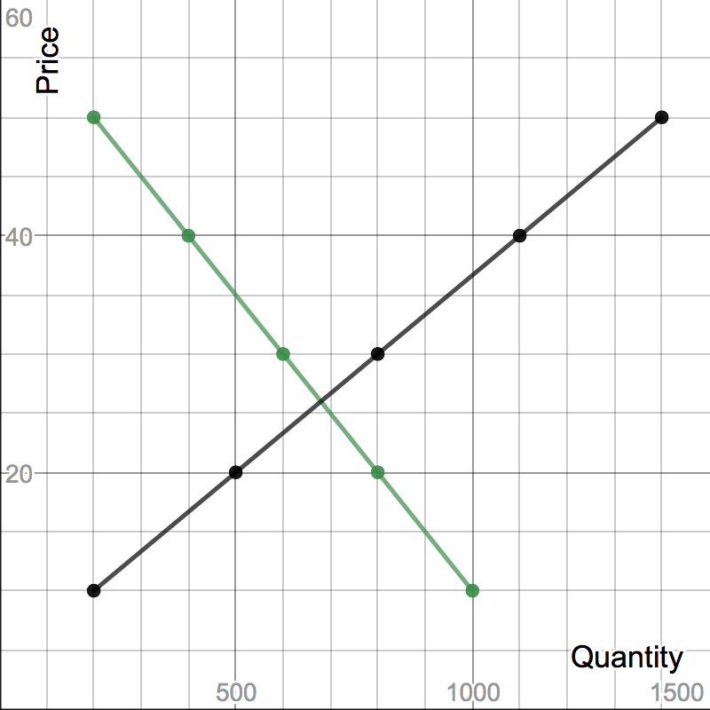



S+T



1. What is the equilibrium price and quantity for DVDs? (1 mark)
2. On the graph above draw a curve showing the imposition of a $10 tax on all DVDs. (1 mark)
3. Explain the impact of the tax on producers, consumers and the government. Refer to the graph in your answer. (4 marks)
4. DVDs are unitary elastic in the price range of $10 to $50. What does this mean and therefore who bears the greater burden of the tax? (2 marks)
5. The government prefers taxing goods that are inelastic. Give two reasons why this would be the case? (2 marks)

**Question 3: Other Elasticities (10 marks)**

1. Define income elasticity of demand. Would the income elasticity of demand for smartphones be negative or positive? Provide a reason to explain your answer. (4 marks)
2. What does it mean when two goods have a positive cross elasticity coefficient? Give an example of two goods that may have a positive cross elasticity coefficient. (3 marks)
3. Using an example, explain the relationship between goods whereby the income elasticity of demand coefficient is equal to zero. (3 marks)